Nepal College of Information Technology
Assessment-2009

Program: BE Time: 3 hrs
Semester: Spring FM: 100
Subject: Electronic Devices PM: 50

- a) What is piece-wise linear modeling? find the piecewise linear model of a silicon diode
with IS. = 10⁻¹¹A and ŋ = 1.6 in the vicinity of Operating point I_{D} = 1MA
b) Describe the effect of temperature on diode characteristics.

- a) Explain the characteristics of zener diode. How it can be used as voltage regulators.
b) For the network below, determine the range of I_{L} and R_{L} that will result in V_{L} being maintained at 10V
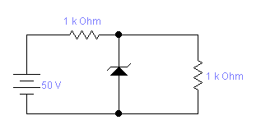
Izm=32maa

1 kΩ
I_{L}
R_{L}
Iz
Fig-(2b)

- a) Describe the input and output characteristics of common emitter configuration of transistor with necessary diagram.
b) For the circuit given below, draw the dc load line and determine the operating point

Fig.3 (b) 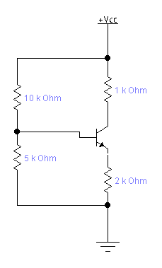

- a) Describe the drain characteristics of N-channel JFET with working principle.
b) For the given JFET in figure, IDss = 10mA , Up = - 4v, find drain current and drain to source voltage when Vgs = -1.5v. Assume it is biased in pinch off region

Fig 4 (b)

- a) Differential between BJT and FET.
b) Sketch the O/p waveform for the circuit shown in figure. it is given that discharging time constant (CRc) is much larger than the time periods of input wave.

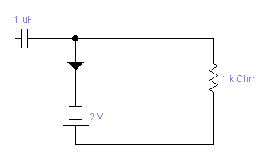
Fig. 5 (b)

- a) What is rectifier? Describe the working principle of bridge full wave rectifier.
b) In given circuit, silicon transistor with β = 100 is biased by base register method. Draw the d.c. load line and determine the operating point. What is the stability factor?
Fig. 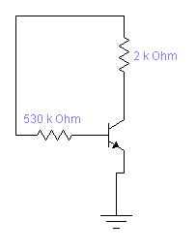
- writer short notes (any two)
- Transistor as an amplifier
- Clippers and clampers
- Working principle of PNP transistor.
- Ripple factor.

